Grade 7 Accelerated · Unit 4 · Assessment  Solving Problems with Rational Numbers  34 points | Name______________________  Date______________________  Period____________________

Show your work. Circle your final answer.
This assessment runs over two class periods. Stop when the period ends; you will continue from where you stopped.
If an earlier part is wrong, a later part still earns its point when the right operation is applied to your own earlier answer — but only if that work is on the page.
1. Operations in Scientific Notation 12 points
1. Add or subtract. Write each answer in scientific notation.
a. 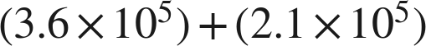 1 pt

b. 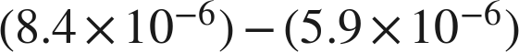 1 pt

c. 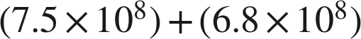 1 pt

d. 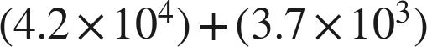 1 pt

2. Multiply or divide. Write each answer in scientific notation.
a. 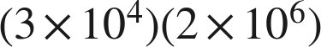 1 pt

b. 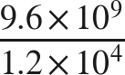 1 pt

c. 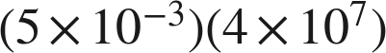 1 pt

d. 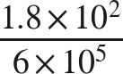 1 pt

3. Which is the value of 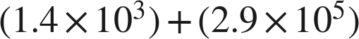 ? 1 pt
○ A. 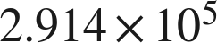
○ B. 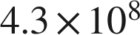
○ C. 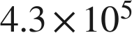
○ D. 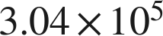

4. Select ALL of the expressions whose value is . 1 pt
□ A. 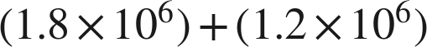
□ B. 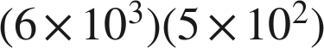
□ C. 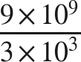
□ D. 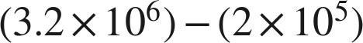
□ E. 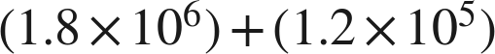
□ F. 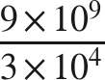

5. Kendra writes . Name the two mistakes she made, and give the correct sum. 1 pt

6. A number is multiplied by 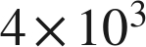 and the product is 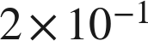. What was the number? Write your answer in scientific notation. 1 pt

2. Real-World Problems and Significant Digits 9 points
7. Give the number of significant digits in each measurement.
a. 3,080 grams 1 pt

b. 0.00405 metres 1 pt

c. 12.500 seconds 1 pt

8. Solve. Report each answer with the correct number of significant digits.
a. A rectangular plate measures  mm by 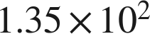 mm. Find its area. 1 pt

b. A vehicle travels 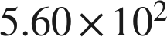 km in 8.0 hours. Find its average speed. 1 pt

9. Solve. Report each answer with the correct precision.
a. Two lengths are measured: 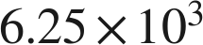 mm and 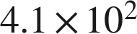 mm. Find their sum. 1 pt

b. Two masses are measured: 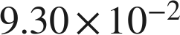 g and 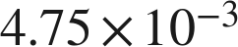 g. Find their difference. 1 pt

10. Jonah adds two measured lengths, 4,560 m and 3.2 m, and says the sum must be written with two significant digits, as 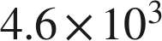 m. Explain why he is wrong, and give the correct sum. 1 pt

11. A rectangle's sides are measured as  cm and 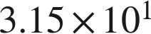 cm. Which is the area, written correctly? 1 pt
○ A. 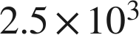 cm²
○ B. 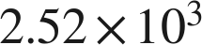 cm²
○ C. 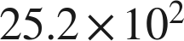 cm²
○ D. 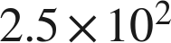 cm²

3. The Order of Operations with Exponents and Radicals 13 points
12. Evaluate each expression.
a. 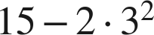 1 pt

b. 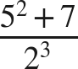 1 pt

c. 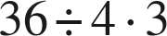 1 pt

d. 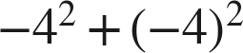 1 pt

13. Evaluate each expression.
a. 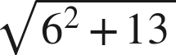 1 pt

b. 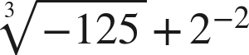 1 pt

c. 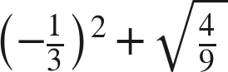 1 pt

14. A square patio of side 14 feet is sealed at 2.40 dollars a square foot, with a flat 85 dollars for delivery.
a. Write an expression for the total cost. 1 pt

b. Find the total cost. 1 pt

15. Which is the value of 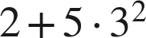 ? 1 pt
○ A. 47
○ B. 63
○ C. 289
○ D. 32

16. Select ALL of the expressions whose value is 6. 1 pt
□ A. 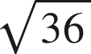
□ B. 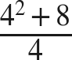
□ C. 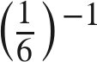
□ D. 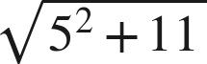
□ E. 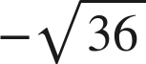
□ F. 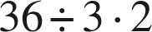

17. Nadia writes . Explain why she is wrong, and give the correct value. 1 pt

18. A square tile has an area of 169 square inches. A second square tile has a side twice as long as the first. What is the area of the second tile? 1 pt

